### **A Project Report on**

**3-TIER ARCHITECTURE WITH AUTOMATIC CI/CD BUILD PROCESS**

**Submitted to**

**VIKRAMA SIMHAPURI UNIVERSITY**

**NELLORE.**



***In Partial fulfillment of the requirements for***

###### **The award of the Degree of**

**Bachelor of Computer Applications**

**By**

**A. SAI SIVA (187190006)**

**DEEPAK RAO (187190026)**

**K. ABHISHEK REDDY (187190051)**

**T. SUDHEER KUMAR REDDY (187190132)**

**J. LOKESH (187190039)**

**Under The Guidance of**

**Smt.B.SUPRAJA**

**M.C.A,M.TECH**

**Assistant Professor in Computer Applications**

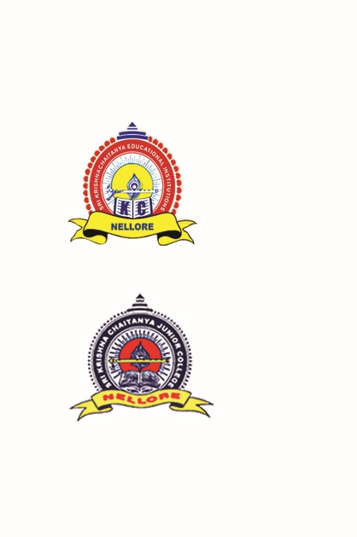

# Department of Computer Applications

# Krishna Chaitanya Institute of Science & Technology

**Nellore,**

**2020-2021**

**KRISHNA CHAITANYA INSTITUTE OF SCEINCE & TECHNOLOGY**

(Affliated to V.S.University)

Nellore.

**CERTIFICATE**

This is to certify that the project entitled **3-TIER ARCHITECTURE WITH AUTOMATIC CI/CD BUILD PROCESS**

submitted in partial fulfillment of the requirement for the degree of

Bachelor of Computer Applications to V.S.University is a bonafide record work

Carried Out By

**A. SAI SIVA(187190006)**

**DEEPAK RAO(187190026)**

**K. ABHISHEK REDDY(187190051)**

**T. SUDHEER KUMAR REDDY(187190132)**

**J. LOKESH(187190039)**

**GUIDE HEAD OF THE DEPT**

**(B.SUPRAJA) (C.V PAVAN KUMAR )**

**EXTERNAL EXAMINERS**

**1.**

**2.**

**Submitted for the project examination held on …………./2021**

## ***Acknowledgement***

We would like to express our heart full thanks our college directors **Sri.Dr. R.V.Krishna Reddy** and **Sri.P.Chandrasekhar Reddy**, and Principal **Sri.Dr. J.N.Ravi Sarin** for helping us to carry out the project in smooth space.

We express our sincere thanks to our guide **Smt. B. SUPRAJA, Assistant Professor in Computer Applications,** who gave valuable guidance at every stage in completing our project in time.

We express our sincere thanks to **Sri.C.V PAVAN KUMAR, HOD, Department of Computer Applications,** who provide lab in completing our project in time.

We also express our sincere thanks to other **Staff Members** of the Department of **Computer Applications** for their helping in project work.

**Our Parents** have been moving spirit behind this work. This acknowledgement is only a small way of showing our love to them, as we just cannot repay them.

1. **SAI SIVA(187190006)**

**DEEPAK RAO(187190026)**

**K. ABHISHEK REDDY(187190051)**

**T. SUDHEER KUMAR REDDY(187190132)**

**J. LOKESH(187190039)**